It’s a Knockout get a team together watch the fun It’s a Knockout get a team together watch the fun It’s a Knockout | 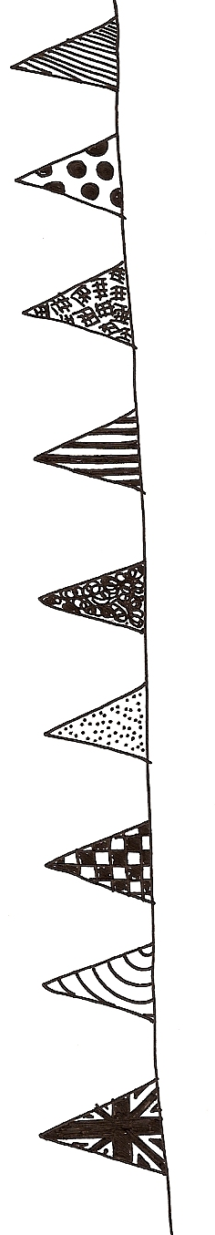  no charge absolutely free no charge totally free no charge all free |  |  | It’s a Knockout get a team together watch the fun It’s a Knockout get a team together watch the fun It’s a Knockout
Saturday 14 June
2pm – 5pm
Jenny Lind Park

Come along and join the fun …

- Make up a team of six
- Free to enter
- Take part in a wide variety of games from ‘Pass the Water’ to ‘Sloping Slalom’
- Or sit back and watch and enjoy the spectacle

Please call 01603 622225 now with the name of your team
 |  | Summer  Festival

