dancing drama workshops crafts football skills dancing drama workshops crafts football skills dancing football | 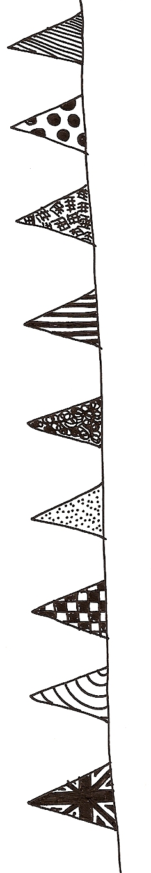  no charge absolutely free no charge totally free no charge all free |  |  |  | dancing drama workshops crafts football skills dancing drama workshops crafts football skills dancing football
 | 
Saturday 7 June
2pm – 5pm
Jenny Lind Park

This is an opportunity to come along and try out something new …
dancing (2pm – 3pm) and drama workshops,
crafts and football skills.
For more information call 01603 622225
 | 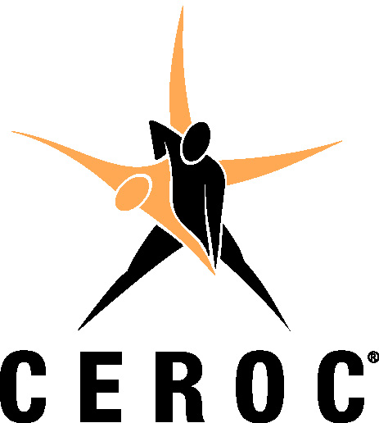  The Ceroc organisation has been introducing people to the world of partner dancing for over 27 years. We teach the stylish form of Modern Jive, which is a fusion of Jive and Salsa that is easy and fun to learn. Going to a Ceroc evening is a great way to meet people, have fun and keep fit all whilst learning to dance. |  |  | 
 |  | Summer  Festival

