balloons snacks drinks ice cream arts and crafts demonstrations organ tunes have your portrait painted | 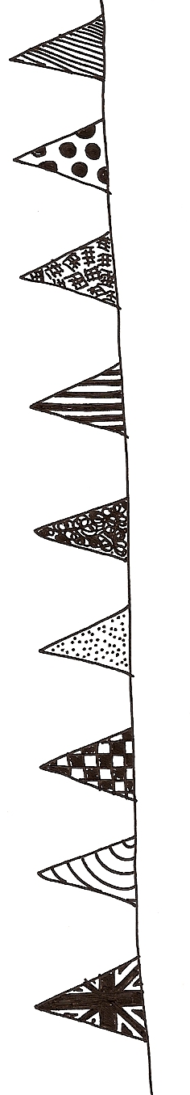  totally free it’s all free absolutely free everything free totally free |  |  | bouncy castle soft play equipment sideshows paint a giant mural quiz round the church 5-a-side football
Fun Day
Saturday 28 June
12noon – 4pm

Holy Trinity Church garden, Essex Street




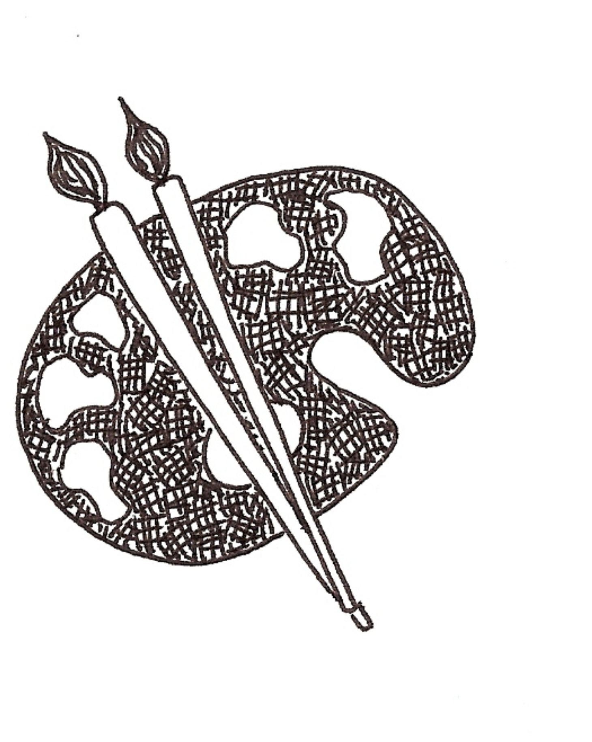


Can YOU show/demonstrate craftwork of your own during the Fun Day?
For more details and to reserve a free space indoors,
please ring Chris Smith ASAP on 01603 453010
 |  | Summer  Festival

