balloons snacks drinks ice cream arts and crafts demonstrations organ tunes have your portrait painted | 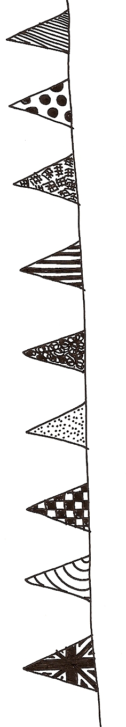  totally free it’s all free absolutely free everything free totally free | bouncy castle soft play equipment sideshows paint a giant mural quiz round the church 5-a-side football
Fun Day
Saturday, 28 June
12 noon - 4pm

in Holy Trinity Church garden, Essex Street
Holy Trinity Summer Festival





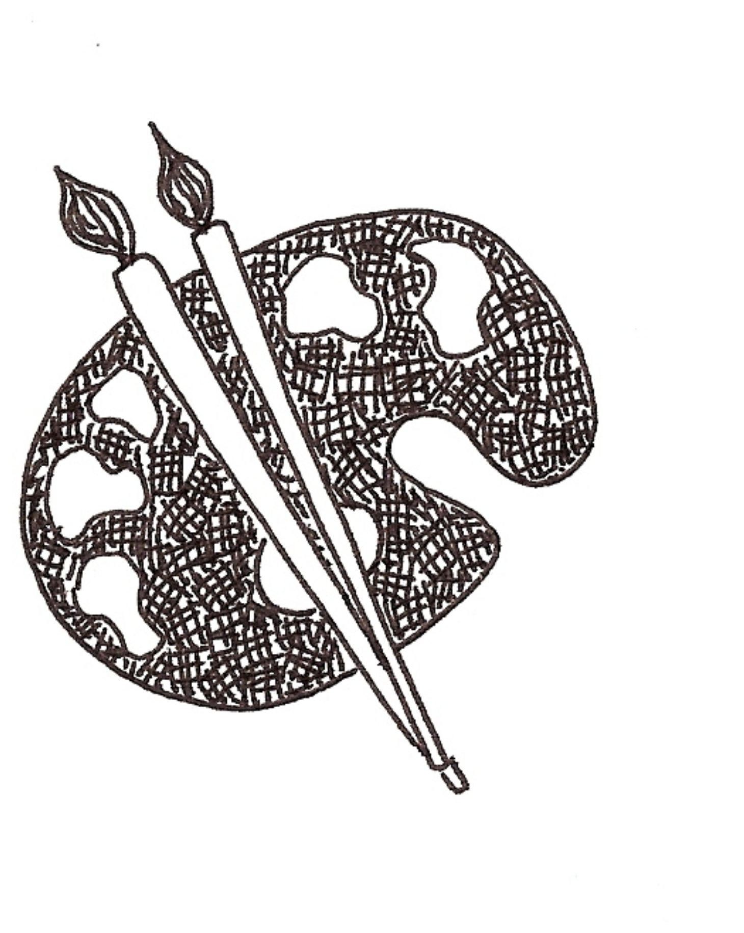


Can YOU show/demonstrate craftwork of your own during the Fun Day?
For more details and to reserve a free space indoors,
please ring Chris Smith ASAP on 01603 453010

